# Lab 5

## Exercise 1: Upload Excel File with an Excel Table

### **Lab Questions**

1. What is the total revenue for Canada in 2014? (to two decimal places)
2. In which year VanArsdel sold the most number of units in Canada?
3. For VanArsdel's Canada sales (Revenue) in 2012, which are the top 4 Provinces?

* Ontario - 1
* Alberta - 2
* British Columbia - 3
* Manitoba - 4
* Quebec

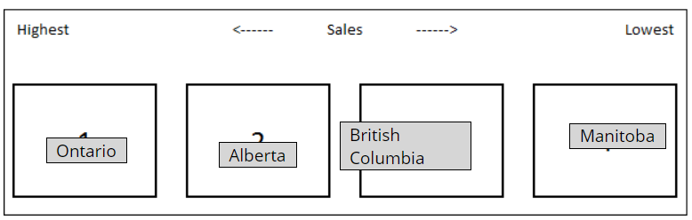

1. What about for the year 2013? For VanArsdel's Canada sales (Revenue) in 2013, which are the top 4 Provinces?

* Alberta - 1
* Ontario - 2
* British Columbia - 3
* Manitoba - 4

Quebec

Correct answer

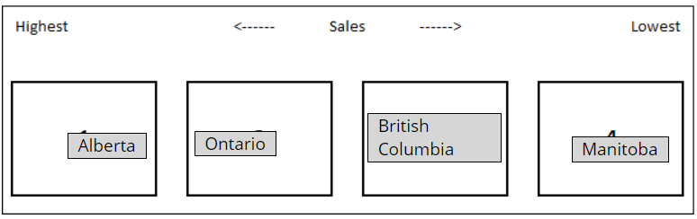

## Exercise 2: Upload an Excel File with a Data Model

### **Lab Questions**

1. Using the Power View1 report, which manufacturer has the most growth in total units between May and June 2015 (for all categories)?

Aliqui

Currus

Natura

Pirum

VanArsdel

1. What about for only the Youth category? Which manufacturer has the most growth in total units between May and June 2015, for the Youth category?

Aliqui

Currus

Natura

Pirum

VanArsdel

1. Which manufacturer(s) does not have products for the Youth category?

Aliqui

Currus

Natura

Pirum

VanArsdel

Note: Make sure you select all of the correct options—there may be more than one!